SAUTI 116 WEBSITE

UI / UX CUSTOMER FEEDBACK TEMPLATE
Reviewer Name (Optional):
Organization / Role:
Date:
Device Used: Desktop
Language Used: ☐ English

How to Use This Template
For each section:
- Review the website section listed
- Compare it against the “Brand & UX Expectations”
- Record your feedback clearly in the Feedback / Observations column
- If possible, include suggested improvements

1. Overall Look & Feel (First Impression)
UI/UX Aspect | Brand & UX Expectations (Reference Standard) | Feedback / Observations
Visual Identity | Looks clearly like Sauti 116; strong, recognizable brand presence; not generic or corporate. | Brand presence is distorted; colors do not match the required codes (blue, green, red, black, light green). Logo needs alignment and the word "National" should be removed.
Emotional Tone | Feels warm, supportive, and reassuring, not intimidating or bureaucratic. | Currently feels alarming due to the choice of colors on the landing page. Photos look like they are only for children rather than being inclusive.
Trust & Credibility | Instills confidence that this is an official, safe, government-supported service. | Instructions given to remove "A Government of Uganda Initiative" and "Official Governance..." from the footer.
Simplicity | Clean layout, not cluttered; easy to understand at first glance. | Font should be reverted to Roboto Sans; all text should be black except for headings to maintain clarity.

2. Homepage
UI/UX Aspect | Brand & UX Expectations | Feedback / Observations
Hotline Visibility (116) | Hotline 116 is immediately visible, bold, and easy to notice on first screen. | Very clear
Call to Action | “Get Help Now” / “Call 116” stands out clearly and encourages action. | Call-to-action buttons currently use the same color and need to be differentiated.
Messaging | Language is clear, simple, survivor-centered, and non-judgmental. | Change "Report violence" to "Report online" or "Click here to report".
Navigation Clarity | Users can easily tell where to click for help, reporting, or information. | Very clear steps
Partner Visibility | Sauti 116 is primary; partner logos support credibility without overpowering. | Partners need to be updated with logos, names, and direct links to their websites.

3. Navigation & Menu Structure
UI/UX Aspect | Brand & UX Expectations | Feedback / Observations
Menu Labels | Clear, simple words (e.g. Get Help, Report a Case); no technical jargon. | Remove "Discover our story" as it does not point to a story. Rename "Helpline updates" to "Updates".
Ease of Use | Users can find what they need within 1–2 clicks. | Save for some non-responsive ones
Mobile Menu | Mobile navigation is easy to open, read, and tap. | Navigation arrangement is distorted and out of order in phone view.
Consistency | Navigation behaves the same across all pages. | Yes, it does

4. “Get Help” Sections
(Child Protection, GBV, Migrants, PSEA)
UI/UX Aspect | Brand & UX Expectations | Feedback / Observations
Clarity of Information | Explains issues in simple, everyday language. | "Migration and displacement" should be changed to "Migrant worker issues".
Survivor-Centered Tone | Language feels compassionate, respectful, and supportive. | Yes very friendly
Action Guidance | Clear steps on what to do and how to get help. | Very clear steps
Visual Support | Icons/visuals help understanding without being distressing. | Very okay
Access to Help | Clear links to call 116, WhatsApp, or report online. | Quite okay

5. Report a Case (Online Reporting Form)
UI/UX Aspect | Brand & UX Expectations | Feedback / Observations
Sense of Safety | User feels safe and reassured when reporting. | Remove "Official secure intake" from the report section.
Confidentiality Messaging | Clear reassurance that reports are confidential. | Yes though reporting as anonymous shouldn’t be there
Anonymous Option | Anonymous reporting is clearly explained and easy to use. | Remove the optionality of the name for the reporter and client.
Form Simplicity | Minimal required fields; not overwhelming. | Turn "Formal incident report" into "report a case." Change "approximate age" to "What is your age." Identity should be "male and female only."
Confirmation Message | Confirmation is warm, reassuring, and explains next steps. | Yes, it is after case reporting

6. Language & Accessibility
UI/UX Aspect | Brand & UX Expectations | Feedback / Observations
Language Simplicity | Content is easy to read and understand. | Yes it is
Multilingual Support | Language switcher is easy to find and use. | n/a
Font Readability | Text size and spacing are comfortable, especially on mobile. | Mobile responsiveness wasn’t okay
Accessibility | Buttons are large enough; contrast is clear. | Yes clarity was okay

7. Visual Design (Colors, Images, Icons)
UI/UX Aspect | Brand & UX Expectations | Feedback / Observations
Color Usage | Uses approved Sauti colors appropriately; feels vibrant yet calm. | They disagreed
Image Choice | Images are respectful, non-triggering, and realistic. | They are okay
Icon Consistency | Icons are clear, consistent, and meaningful. | They are okay
Overall Balance | Visuals support the message without distraction. | They are okay

8. Mobile Experience
UI/UX Aspect | Brand & UX Expectations | Feedback / Observations
Load Speed | Pages load quickly even on slow internet. | Okay
Tap-to-Call | Calling 116 works easily on mobile. | Okay
Touch Interaction | Buttons and links are easy to tap. | Floater needs to explain more using a hover effect.
Layout | Content fits well on small screens without confusion. | Arrangement is currently distorted and out of order in mobile view.

9. Content Tone & Messaging
UI/UX Aspect | Brand & UX Expectations | Feedback / Observations
Call-to-Action Language | Encourages action without pressure or fear. | Abit to “in your face”
Consistency | Tone is consistent across all pages. | Has too vibrant colors
Survivor Respect | No blaming, shaming, or harsh wording. | It is respectful
Empowerment | Content makes users feel supported and capable of seeking help. | Save for the colours

10. Overall Assessment
Question | Response
Does the website feel like a safe place to seek help? | ☐ Yes
Is it clear what Sauti 116 does and how to get help? | ☐ Yes
Would you recommend this website to someone who needs help? | ☐ Yes

11. Key Strengths

- Editing of features
-fetching from helpline
-statistics

12. Key Areas for Improvement

- They were okay with the last theme they had and they had requested for a lot of changes only to see that the changes were not there and instead something new was there. (the initial request was to make the buttons align with the color codes )
- The landing page has alarming colours
- The supervisors thought they were done with the meeting.
- The photos doesn’t look to shape up to be a inclusive website , just looks to be for kids and needs revision.
- In phone view the arrangement is distorted ie.not in order
- Reset colors to original and theme is not good.
- Our journey has been distorted (structure , colours – blue, green ,red ,black and light green)
- Remove the word national and align the logo , maintain the same font as was in the first website. (roboto sans)
- All font to be black save for when there is a need eg heading
- The call-to-action buttons can’t be the same color
- Emphasis on the colour code being maintained
- A Government of Uganda Initiative- to be removed.
- Remove discover our story - not pointing to the story
- Phrasing of the services offered - headings.
- Helpline updates to Updates then fix the click function.
- Edit and update the partners with logos as well (partner name – logo – link to the website)
- Remove the “official governance ….” From the footer and make the footer editable.
- TikTok link in the social media and also have twitter icon as the x.
- Report violence to report online / click here to report
- Have the floater explain more with hover effect.
- Have an option in the backend for editing the privacy policy
- Official secure intake to be removed from the report section
- Formal incident report turned to report a case
- Start by asking who is reporting ie by themselves or for someone – ie revert itback to how it was.
- Remove the optionality of the name for the reporter and the client
- Remain with myself and someone else remove the rest of the list
- What is your age instead of approximate age
- How do you identify – male and female only
- Include examples on the issues / under the choice of harm add the subcategories of child abuse
- Add GBV in bracket – have explanations and abbreviations
- Migration and displacement to change to migrant worker issues
- Remove something else
- In the location narrow down the example eg . Wakiso, Kireka
- In report for another person start by capturing the information of the reporter ie the sex location age name and contact
- Too much space in the about page and the photos as well.
- Quick statistics on the about page (avg calls per day 1500+), (40k+ cases handled)(2.6M + calls received)
- Our national impact to our impact
- The core values should be color coded / add colors
- Our Journey – revert to what was there.
- Remove the trusted patners from the about page
- Revert back to what was there.
- Updates in home, Blogs and videos in their own pages.
- Official videos to change to videos and multimedia.
- Remove browse resources
- Uploading videos fails even though the url works – youtube
- Impact dashboard to have what was on the original website 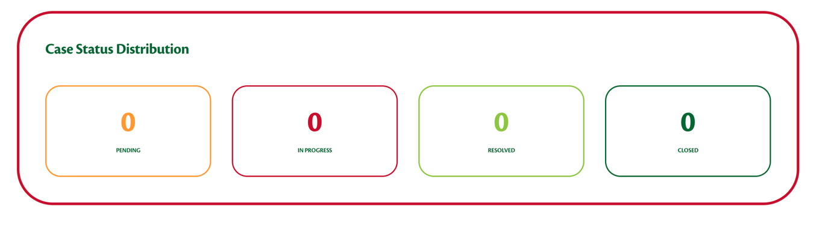to be removed.
- 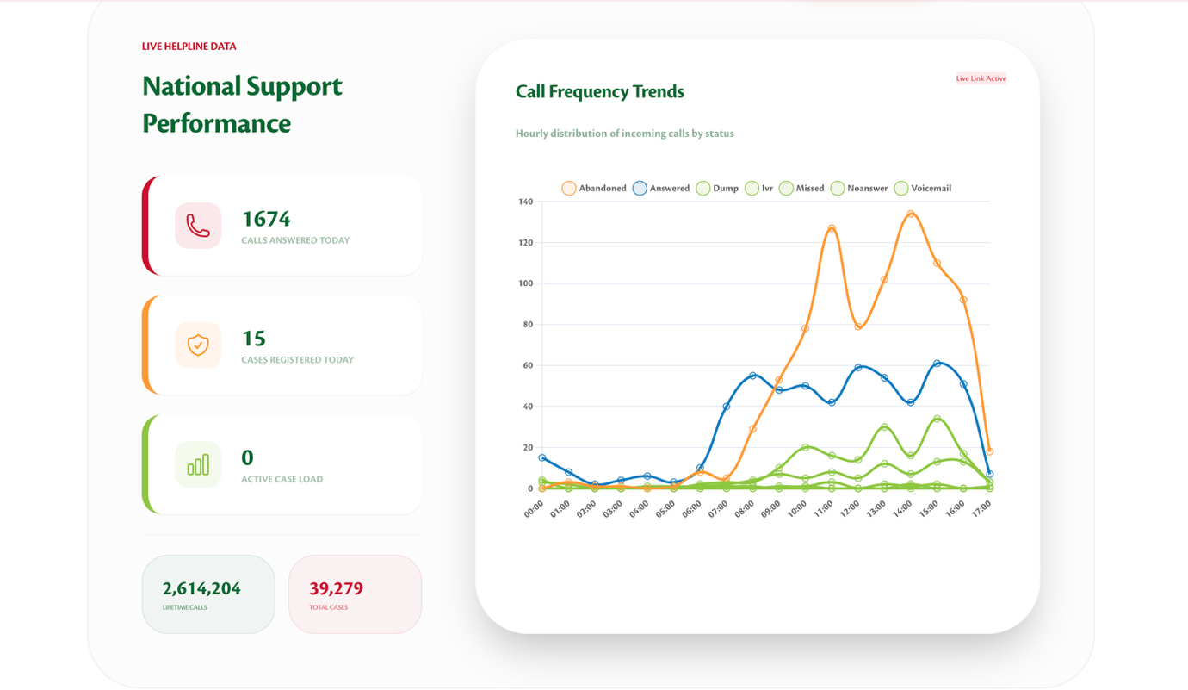to be removed.
- Removed statistics since it is too much operational and not for all the users to see.
- In the need immediate help in the FAQs page add the click here to report
- Change twitter to x , add tiktok , then also color code them
- In the backend there should be a notification for messages.( cleaned up well ie the labelling of the parts.)
- The backend should edit the text in the frontend and well user friendly labelled.

13. Additional Comments or Suggestions

Declaration
This feedback focuses on user experience, usability, and brand alignment of the Sauti 116 website.

